27

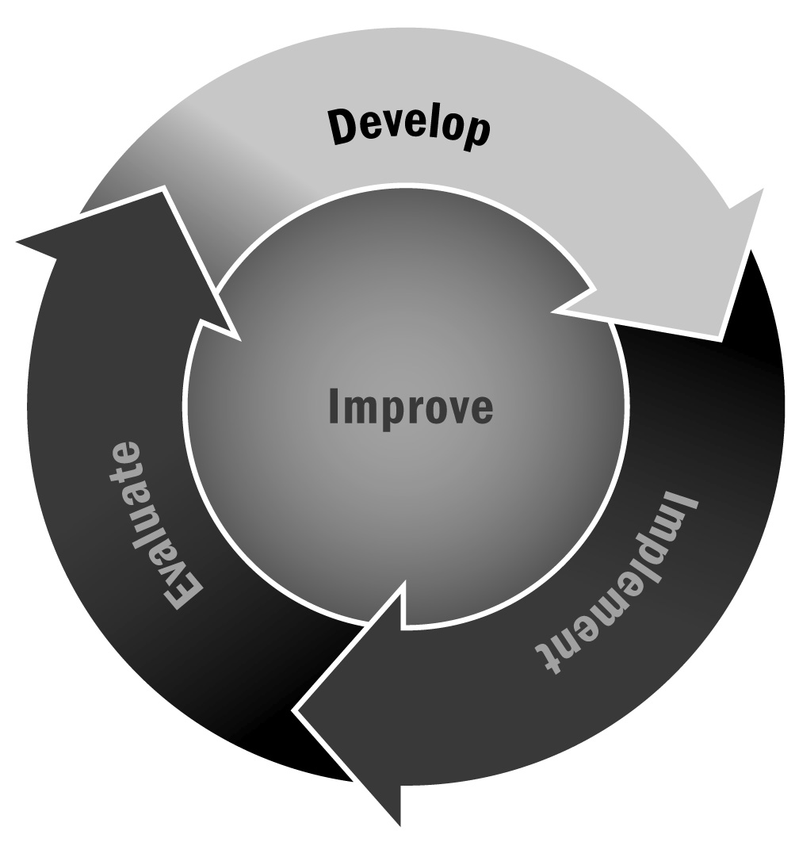
Staff Satisfaction Survey
In Chapter 1, you learned that creating a supportive environment where staff members feel valued and supported will lead to a higher quality and smoother functioning program. Use the staff satisfaction survey on the following pages to gauge staff members’ satisfaction with their jobs and roles.
Directions: Have staff members complete the survey on the following pages by indicating their level of satisfaction with each area. You can add other items to the list if there are additional areas in which you want to get staff input. You may choose to make the surveys anonymous to achieve a greater level of honesty. This will give you general information that you can use for improvement. If you have a high level of trust with your staff, consider asking them to put their name on the survey to get specific information about their satisfaction. Note: If you are unable to make changes (e.g., to wages), be sure to discuss areas of dissatisfaction with your staff and explain why you can’t make a change. Reassure your staff that you will work to address their needs in other ways (e.g., through other means of recognition that aren’t financial).

Tips for Developing and Administering Surveys (For a Full List, See Tool 87)
- Consider your goals and expected outcomes for the survey. What are you trying to learn? Design a survey and develop questions that will help you achieve those goals and answer your ultimate question.
- Make sure you are familiar with the legal and institutional requirements, if any, when surveying families, community members, and especially youth.
- Prioritize your selection of survey questions.
- Consider your audience and make sure your survey will be understood easily.
- Write short questions that respondents can read quickly and easily.
- Make sure that each question has one central idea.
- Focus your questions on suggestions for improvement rather than focusing on negative experiences.
- Avoid leading questions that appear to advocate a particular answer.
- Provide instructions on how to record answers and how many options to select.
- For multiple choice questions, allow respondents to select “Other” so that they can provide a response that wasn’t included in the options.
- Test your survey with a small group before distributing it to all of your intended respondents.
- Think about how you will deliver the survey. Will it be delivered by mail, by telephone, in person, or online? These different methods will affect the survey design. It is likely that a paper survey will be the most convenient for respondents, but an electronic survey has advantages as well (such as allowing for skip logic and requiring less data entry) if it seems like a viable format for your respondents.
- Provide respondents with a contact person whom they can reach if they have any questions or concerns about the survey.

Staff Satisfaction Survey
Directions: Please check the box under the number that most closely matches how you feel about each area using the response categories below.
4 Very Satisfied
3 Satisfied
2 Dissatisfied
1 Very Dissatisfied
 | 4 | 3 | 2 | 1
Salary | ❒ | ❒ | ❒ | ❒
Benefits | ❒ | ❒ | ❒ | ❒
Workload | ❒ | ❒ | ❒ | ❒
Flexibility of work hours | ❒ | ❒ | ❒ | ❒
Job security | ❒ | ❒ | ❒ | ❒
Physical work environment | ❒ | ❒ | ❒ | ❒
Ability to influence decisions that affect you | ❒ | ❒ | ❒ | ❒
Opportunity to participate in program planning and decision-making | ❒ | ❒ | ❒ | ❒
Opportunity to work on interesting projects | ❒ | ❒ | ❒ | ❒
Access to professional development opportunities such as training and seminars | ❒ | ❒ | ❒ | ❒
Communication with supervisor | ❒ | ❒ | ❒ | ❒
Recognition for work | ❒ | ❒ | ❒ | ❒
Relationship with peers | ❒ | ❒ | ❒ | ❒
Relationship with youth | ❒ | ❒ | ❒ | ❒
Relationship with program partners | ❒ | ❒ | ❒ | ❒
Understanding of the mission of the afterschool and expanded learning program | ❒ | ❒ | ❒ | ❒
Overall satisfaction with the afterschool and expanded learning program | ❒ | ❒ | ❒ | ❒
Overall satisfaction with your job | ❒ | ❒ | ❒ | ❒

If you marked dissatisfied or very dissatisfied for any category, please say why in a few words below.
Area(s):
Reason:

If you marked very satisfied for any category, please say why in a few words below.
Area(s):
Reason:

